## **Exercise:**

**﻿﻿  
﻿﻿**

**Say out loud, two times:**

*"Improving data quality is really important."*

**﻿﻿  
﻿﻿**

**1) The first time, you use Uptalk. So you go up with your voice at the end of the sentence (the word "important" with a high pitch, like you're asking a question).**

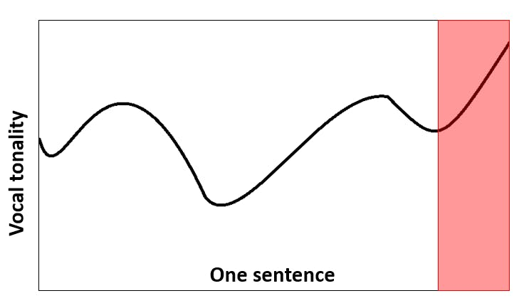

**﻿﻿  
﻿﻿**

**2) The second time, you go down with your voice at the end of the sentence.**

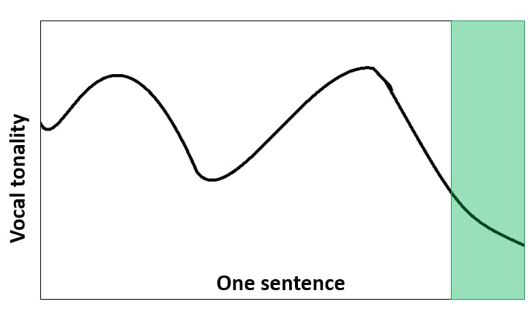

**﻿﻿**

**Now, try it again with a different sentence.**

**This time, say the following:**

*"The adoption rates of our dashboards need to improve."*

**﻿﻿  
﻿﻿Say it twice (1x going up at the end, 1x going down).**

**﻿﻿  
﻿﻿**

**Do you feel the difference?**

**Your audience feels it too.**﻿﻿